Males Get Paid More than Females, Regardless of Education or Age

*Mohammed Furqan Mehboob*

The University of Texas at Austin

**Purpose/Objectives:** The question of whether males and females receive equal pay, even with education and age levels, was answered. Data was given from wageGenderEduAge.csv file and the data were divided into different categories. These categories were: wage, education, age, and gender. Graphs were made to see if there were patterns in the data and from those patterns, the question was answered.

**Graphs/Results:**

On a general level disregarding education and ages, do both genders get paid the same? This question was answered through a histogram that has a Kinetic Density Plot (KDE) plotted over it. The graph is shown here:

**Figure 1.** Histogram of wages by gender.

The figure above shows that males in fact do get paid more than females overall. Towards the end where the wages are higher, males have a much higher count than females while the opposite occurs in the lower wages. This is a clear indication that on a general level, males do get paid more than women.

However, what about education or age? Do both genders get paid equally at those levels? To answer this question, two different scatterplots were made. These two plots can be seen here:

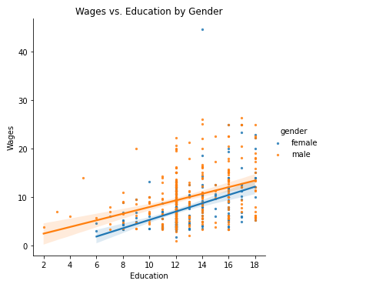

**Figure 2.** Scatterplot ofwages by education and gender.

**Figure 3.** Scatterplot of wages by age and gender.

Figures 2 and 3 above reinforce the idea that males get paid more than females, regardless of education or age. On both graphs, the male regression line is a lot higher than the female’s line throughout the entire x-axis. Due to this, it can be confirmed that males do get paid more than females.

However, is that the only evidence there is? Well, a joint plot was made to further indicate if this conclusion is true:

**Figure 4.** Joint plot of Wages by Age and Gender

**Figure 5.** Joint plot of Wages by Education and Gender.

Figures 4 and 5 above demonstrate the same conclusion as before. The males dominate both factors because the graphs are dominantly orange rather than blue. Even though education does have slightly better results for females, the overall general conclusion is that males do in fact get paid more than women.